Victoria ALIVE
Outer Eastern Metro Community Forum

Creating meaningful opportunities in our organisations for volunteers with a disability.

Venue: Matsudo Room, Box Hill Town Hall,
1022 Whitehorse Rd, Box Hill VIC 3128
Enter via the main entrance at the top of the circular driveway
(see appendix A & B – location and venue map)
Transport:
Train: Lilydale & Belgrave train lines stop at Box Hill Station
Box Hill Station is located within Box Hill Central Shopping Centre.
Box Hill Town Hall is approximately a 10-minute walk from the station.
(see appendix C for map and directions)
Tram: Tram Route 109 (stop 58) stops on Whitehorse Road
Box Hill Town Hall is approximately a 6 minute walk from the tram stop, down Whitehorse Road.
Car/Parking: There is street parking in the surrounding streets including Whitehorse Road and Bank Street however, please note this is metered at $2.70 p/hour and strictly limited to 2 hours. Holders of a blue disability parking permit are entitled to double the allocated parking time and are exempt from ticketing/meter fees
All day parking is available at nearby multi-level car parks including:
http://www.carepark.com.au/find-a-care-park/watts-street-box-hill/
http://www.aceparking.com.au/find-parking/990-whitehorse-road-box-hill/
Parking is also available at Box Hill Central Shopping Centre at an hourly rate. Box Hill Town Hall is approximately a 10-minute walk from Box Hill Central.
https://www.boxhillcentral.com.au/centre-info/parking/

Disability parking is available on the circular driveway leading to the main
entrance of the town hall. There are two designated spots. Additional disability
parking on the driveway will be allocated during the event. Please contact the event
organisers so that we can ensure appropriate parking is arranged.
Appendix A: Venue location
Box Hill Town Hall, 1022 Whitehorse Rd, Box Hill VIC 3128
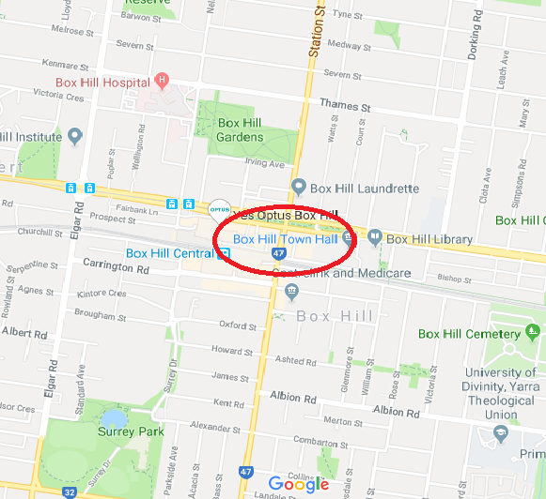
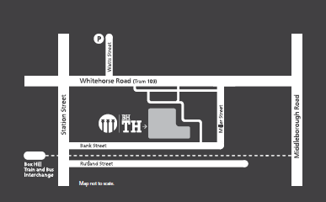

Appendix B: Venue map
Matsudo Room, First Floor
Box Hill Town Hall

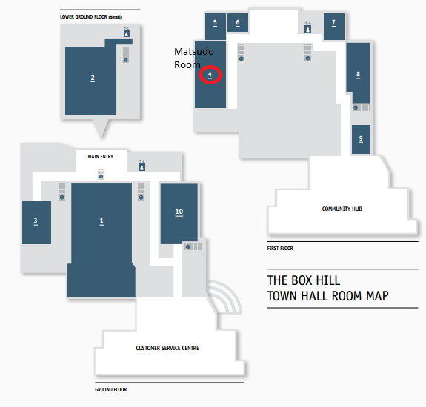

Directions
Enter Box Hill Town Hall via the main entrance from Whitehorse Road at the top of the circular driveway
For stair access, turn right and proceed up the stairs to level 1, the Matsudo room is to the left, at the top of the stairs
For life access, turn left and proceed in the lift to level 1, the Matsudo room is to the right on exit from the left

Appendix C: Transport map & directions

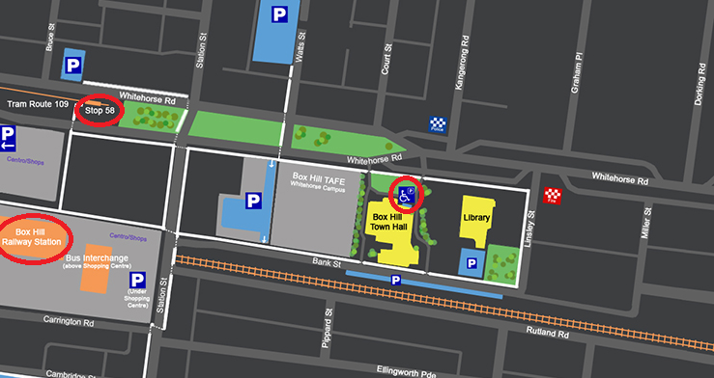

Walking directions from Box Hill Train Station/Box Hill Central Shopping Centre
- Take escalator / lift to shop level (from train station)
- Exit from the building through the doors to your left (into the mall)
- Turn right towards Station Street.
- Use the underpass under Station Street (ramp and stair access available)
- Comes out on Bank Street - walk forward down Bank Street (away from Station Street).
- There is an empty block on the left. The white building next to it is the Town Hall.
- Turn left up the rear side driveway, and continue to the main driveway
- Turn right towards the main entrance located at the top of the driveway

