Victoria ALIVE
Cobram Community Forum

Creating meaningful opportunities in our organisations for volunteers with a disability.

Venue: Council Chambers, Cobram Civic Centre
Punt Road, Cobram VIC 3644
Enter via the Main Entrance facing Punt Road
(see appendix A- venue maps)

Transport:
Train: The closest V/Line train station is Shepparton.

Bus: V/Line coach services operate throughout Moira Shire surrounding areas
The closest stop Cobram Station / Punt Road
Cobram Civic Centre is approximately a 9-minute walk from the bus stop
(see appendix B - transport maps & walking directions)

Car/Parking: Limited car parking places are available onsite.
Street parking is also available in the surrounding streets.

Disability parking is available in the Eastern Car Park of the Civic Centre.
There are two designated spots. Please contact the event organisers if you require
disability parking access so that we can ensure appropriate parking is arranged.

Appendix A: Venue location
Cobram Civic Centre, Punt Road Cobram, VIC 3644

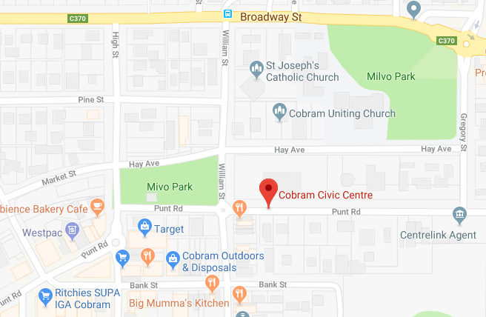

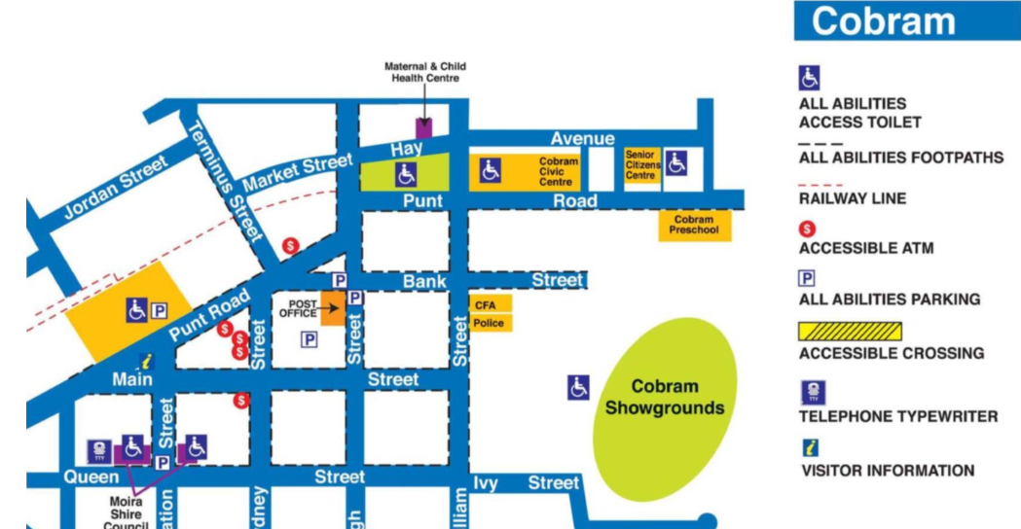

Appendix B: Transport map & directions
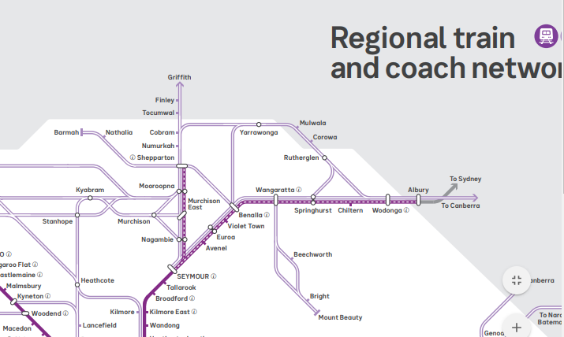

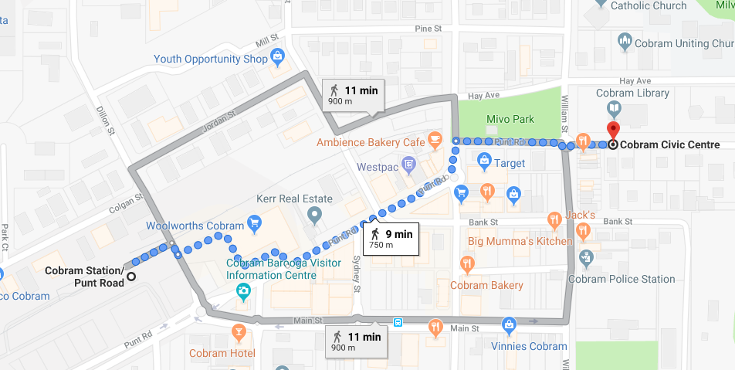

Walking directions from Cobram Station/Punt Road
- Walk north-east towards Dillon Street; turn right onto Dillon Street
- Continue left towards Punt Road
- Turn left onto Punt Road
- At the roundabout take the 1st exit onto High Street
- Turn right onto Punt Road and walk through one roundabout
- Cobram Civic Centre is 200m on the left

