Victoria ALIVE
Geelong Community Forum

Creating meaningful opportunities in our organisations for volunteers with a disability.

Venue: Hinchcliff Room, Eastern Hub,
285a McKillop Street (corner of Humble Street)
East Geelong, VIC 3219
Enter via the Main Entrance facing the corner of McKillop & Humble streets
(see appendix A & B – location and venue maps)

Transport:
Train: V/Line train and coach services operate throughout Greater Geelong and
neighbouring shires to Geelong Railway Station (see appendix C – transport maps)

Bus: Geelong city bus services (including those from Geelong Railway Station) travel
via nearby Ormond Road in East Geelong
The closest stop is Humble Street/Ormond Road
Eastern Hub is approximately a 6 minute walk from the bus stop
(see appendix C - transport maps)

Car/Parking: Limited car parking places are available onsite.
Street parking is also available on McIntyre, Humble and McKillop streets.
There are no time restrictions on street parking, except on the west side of Humble street which is 2 hour parking (see appendix A – venue / car park map)

Disability parking is available in Car Park 1 leading to the main
entrance of the town hall. There are two designated spots.
(see appendix A – venue / car park map)
Please contact the event organisers if you require disability parking access so that we
can ensure appropriate parking is arranged.

Appendix A: Venue location
Eastern Hub, 285a McKillop Street (corner of Humble Street), East Geelong, VIC 3219
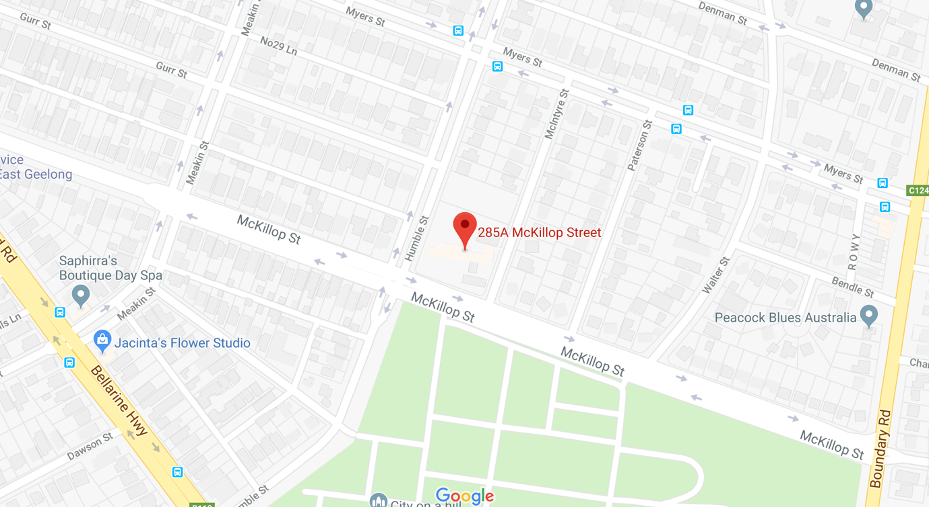

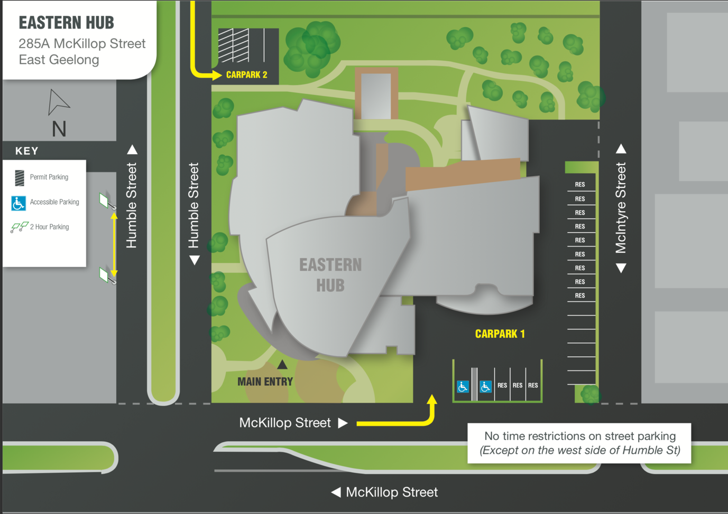
Appendix B: Venue map
Hinchcliff Room
Eastern Hub Geelong

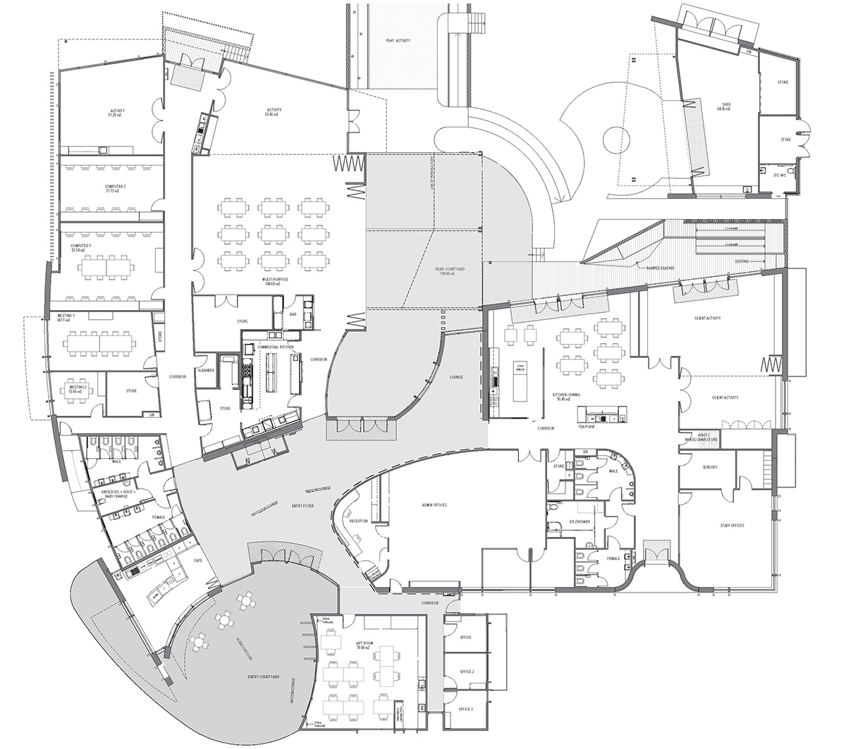
Hinchcliff Room
Main Entrance

Directions
Enter the Eastern Hub through the front courtyard leading to the main entrance on the corner of McKillop and Humble Streets
Proceed down the far left corridor leading from the Entrance foyer
The Hinchcliff room is through the third set of doors on the right

Appendix C: Transport map & directions

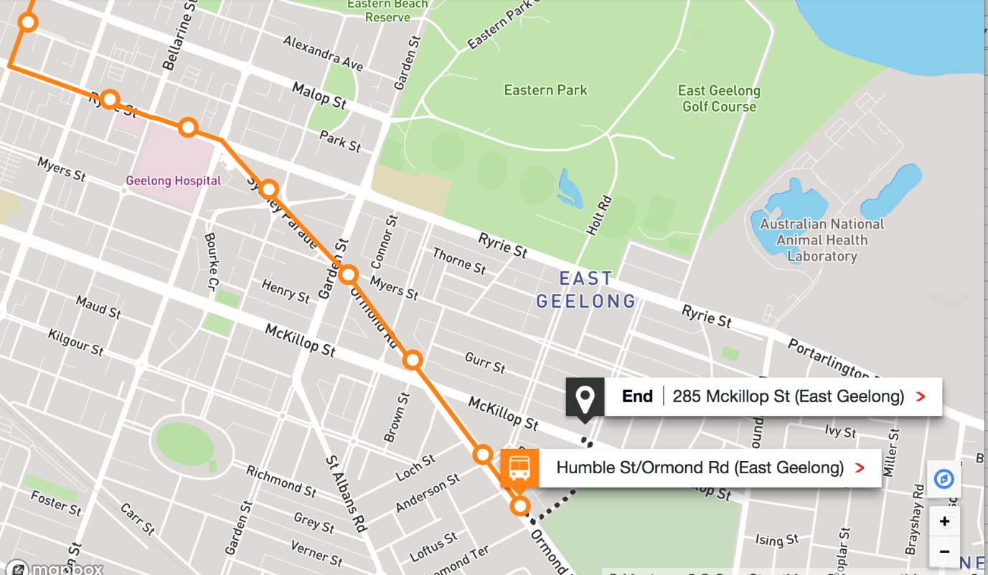
Walking directions from Humble St/Ormond Road (East Geelong)
- Continue along Ormond Road towards Humble Street
- Turn left on Humble Street
- Turn left on McKillop Street
- Turn right towards the main entrance located on the corner of McKillop and Humble Street

