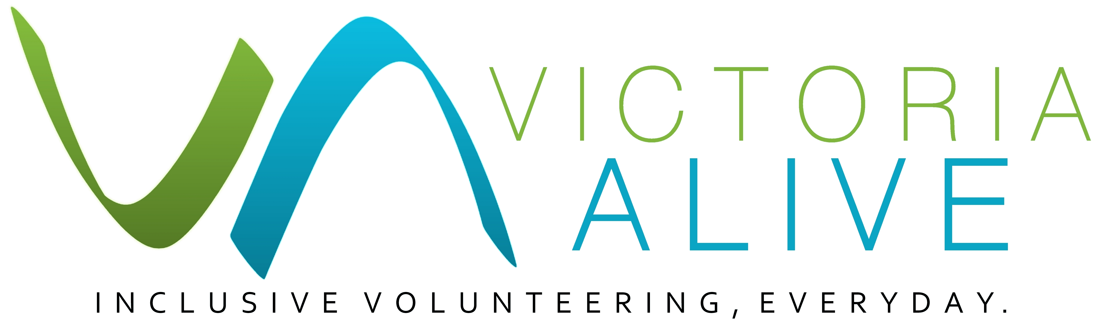
A Disability Action Plan is one of the most effective ways of starting to change an organization.

What is a Disability Action Plan?
A Disability Action Plan (DAP) is a document that makes goals around organisational inclusion and accessibility and sets out practical steps to achieve those goals. Goals can be wide-ranging and related to general accessibility, employment and volunteering. A DAP demonstrates a commitment to diversity and inclusion and helps to keep your organisation accountable for making improvements.
A DAP does not have to be long and comprehensive. Small, consistent improvements add up over time. Even a short document can make a big difference to your organisation’s accessibility.
Disability Action Planning
Guide
Organisational benefits for having a DAP include:
- Having a plan and strategies to address the barriers to inclusion faced by your organisation
- Affirmative measures for your employees and volunteers will attract the most motivated and skilled people for positions which will improve and strengthen your workforce
- Better service to your clients or customers by demonstrating your organisation is accessible, inclusive and values diversity
- Improved organisational culture and staff attitudinal change, likely lowering the risk of discrimination or complaints.

Goals for inclusive volunteering
Every volunteer and every organisation is different so you should independently consider your needs and the ways your organisation can be inclusive. It is also important to engage and consult and with volunteers living with disability to ensure your goals are relevant and represent the interests of the community. Consider the following aspects of volunteering and some ideas for actions you can take.

Disability Action Plans and Volunteering
Volunteers are an important but sometimes overlooked part of an organisation’s workforce. By ensuring your organisation and DAP includes affirmative measures for your volunteers, you will improve and broaden your volunteer workforce.

Some simple ways your organisation might be able to improve its DAP to include volunteers are to:
- Seek input and feedback on your DAP from your existing volunteers. At a time when good user experience is becoming more important and expected, their experience and suggestions are a valuable resource to draw upon
- Seek advice from people with disabilities, or their representative organisations, on best practice in inclusion of people with disability as volunteers in your organisation
- You might create a disability advisory committee made up of staff and volunteers to oversee the process and implementation
- Consider whether existing or new volunteers can contribute to the outcomes of your DAP. For example, to support people with vision impairments or who are Deaf or hard of hearing, you might use existing volunteers to caption or develop audio descriptions of your content
- Broaden the initiatives you have for your employees to also include your volunteers. For example, consider making disability awareness training which is available to employees to also be available to volunteers.
Make sure your DAP is available to volunteers, preferably as a publicly available document. You can register your DAP here: www.humanrights.gov.au/our-work/disability-rights/action-plans-and-action-plan-guides

Volunteer position descriptions
Best practice as recommended by Volunteering Victoria is to clearly and routinely scope volunteer roles and develop Position Descriptions for your volunteers. Over time position descriptions can become standardised and contain requirements that are unnecessary which create barriers for people with disability.
- Does the volunteer need a driver licence to perform the role?
- Do they need to do heavy lifting?
- While a clear role scope is preferable, are you able to be flexible with your requirements and is this noted in the position description?
- Can the role be divided or shared by two volunteers?
- Do you indicate that you are welcoming of people with disability, and other groups of people? It is important not to be tokenistic but including an affirmative or welcoming statement in your position description will likely welcome a greater pool of talent.

Example DAP goal: review your volunteer roles and update them where appropriate.

Recruiting volunteers
If you don’t already, you can advertise your volunteer position on www.govolunteer.com.au This website has the option for you to advertise your role as one that is suitable for a people with disability and outline your organisation’s accessibility.

Consider promoting your volunteer roles through disability services or disability employment agencies to reach a wider pool of people.

If you recruit volunteers through your website, is it clear and accessible? Is the font and text readable for assistive technology and software? Is the pathway to volunteer opportunities prominent?

Example DAP organisation goal: partner with a disability employment service to provide volunteer opportunities to people with disability.

Managing volunteers
A person with a disability has likely been overcoming obstacles their whole life. In some cases, a person’s accessibility requirements may require more time and patience of the volunteer manager. But you might be surprised what people are capable of if you give them the opportunity and support.
Example DAP organisation goal: establish a mentor or formal buddy system to support the volunteer manager and new volunteers of all abilities.

Leadership and consumer feedback
1 in 5 people in Australia has a disability. A diverse range of viewpoints adds value to your governance and benefits your whole organisation.

- Is your board diverse and reflective of the amount of people with disability in Australia?
- Could you set diversity targets or take affirmative measures to diversify areas of your organisation?
- Do you advertise opportunities specifically seeking volunteers and committee member from diverse communities?
- Do you collect feedback through exit interview/surveys at the end of a volunteer relationship?

Example DAP organisation goal: Establish a Disability Advisory Committee or consultation process for people with disability.

Disability Action Plan Template
Disability Action Plan template and more ideas for your organisation is available in the resources section of the Victoria ALIVE website: www.victoriaalive.org.au/resources

Further help
For guidance on developing your plan and other aspects of accessibility visit:
https://providers.dhhs.vic.gov.au/disability-action-plans
www.humanrights.gov.au/our-work/disability-rights/action-plans-and-action-plan-guides
For examples of disability action plans visit:
www.humanrights.gov.au/our-work/disability-rights/register-disability-discrimination-act-action-plans

Published by Volunteering Victoria for the Victoria ALIVE project (2018-2019). For more resources visit: www.victoriaalive.org.au
This guide was peer-reviewed by the Disability Advocacy Resource Unit (DARU). For more information visit: www.daru.org.au/
If you have any suggestions for improvements to this guide, we welcome your input.
Contact us by email at: alive@volunteeringvictoria.org.au or by phone on 03 8327 8501.
Guide version 1.0. Published September 2019. Volunteering Victoria is the state peak body for volunteering. ABN 79 378 017 212. www.volunteeringvictoria.org.au
Volunteering Victoria is unable to provide legal advice and this information should not be relied upon as a substitute for legal advice.

03 8327 8501 | alive@volunteeringvictoria.org.au | victoriaalive.org.au

