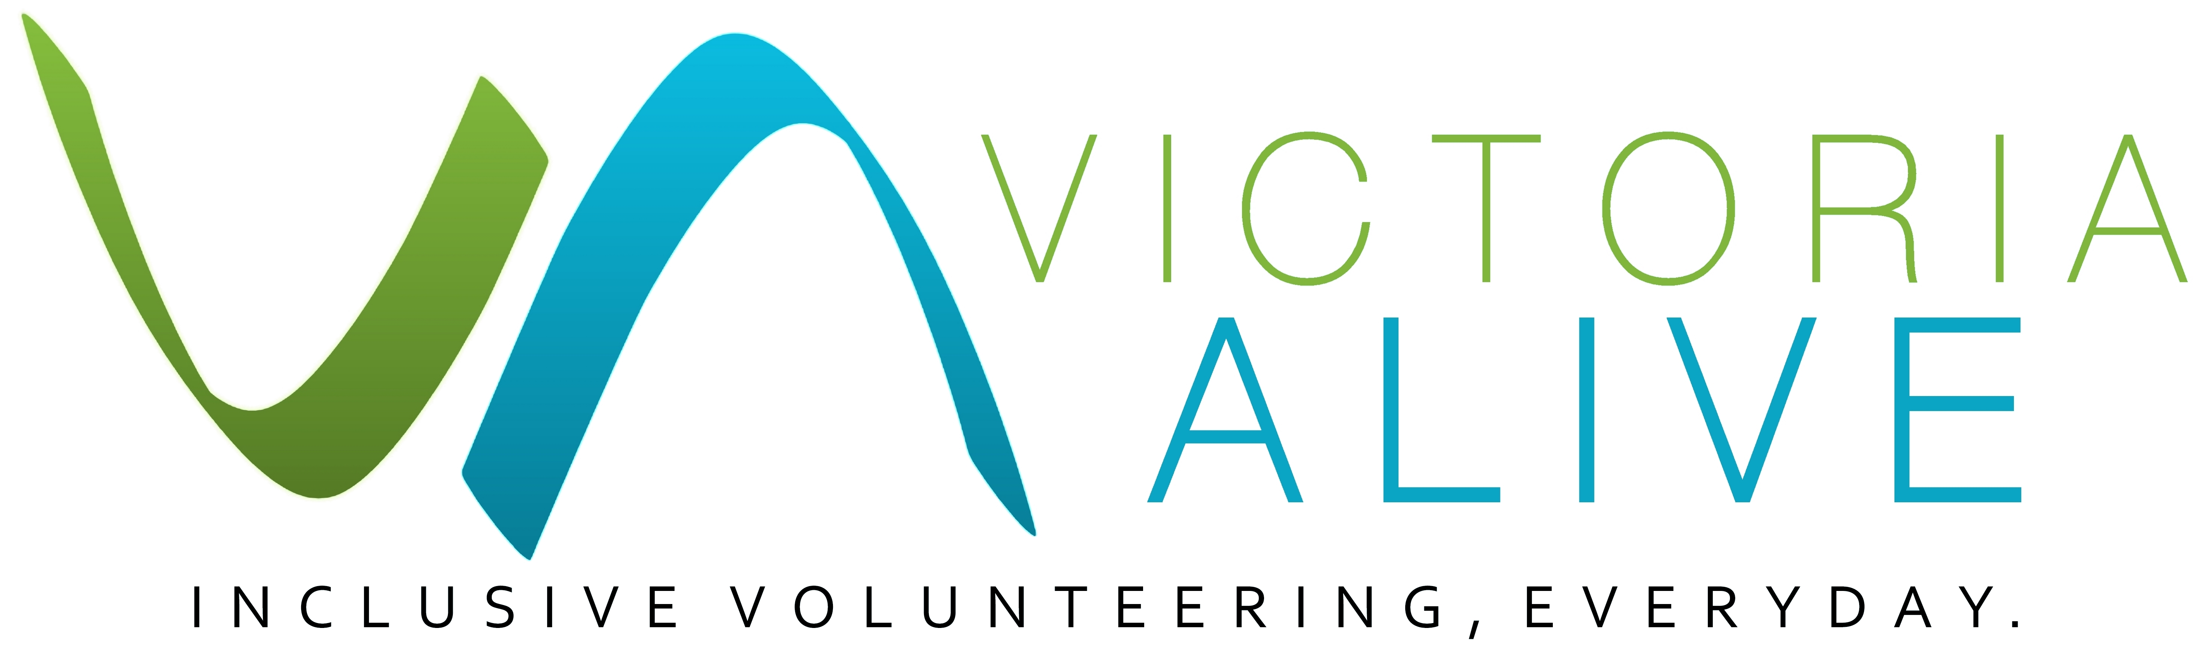
Volunteering attracts a diverse range of people. This diversity brings with it the need to consider different approaches to communication based on the individual volunteer. In the case of people with disabilities, there are a number of key communication considerations and actions that organisations need to be aware of.
Effective Communication
Guide

This guide is a resource for organisations engaging volunteers with a disability and will help your staff to better communicate with this group of people, to ensure that the volunteering experience is as beneficial and rewarding as it should be.

What do we mean by disability?
According to the Australian Network on Disability, over 4 million people in Australia have some form of disability. That's 1 in 5 people. Disabilities can take many forms including blindness, deafness, mental health conditions, people who use a wheelchair and physical disabilities, plus more.
In Australia, the employment rate for people with a disability is 47 percent (Access Economics 2017). Volunteering roles often provide a valuable opportunity for people with disability to gain work experience and like everyone else, give back to their community to causes that interest them. Not all disability is visible.
There are many benefits to engaging volunteers with disability at your workplace. According to the Department of Industry, Innovation and Science, evidence has shown people with a disability tend to:
- Take fewer days off, take less sick leave and stay in jobs for longer than other workers
- Have fewer compensation incidents and accidents at work compared to other workers
- Build strong relationships with customers
- Boost workplace morale and enhance teamwork

- Add extra value and a unique, diverse perspective to your business that you have not had access to before.
Effective communication
If a person’s disability effects their capacity to communicate – such as deafness, autism or intellectual disabilities - you should try a range of approaches to communicate effectively.

Communication considerations
While communication with your volunteers is ongoing, there are some key points of interaction you may want to purposefully reflect on.
The most important thing of all is to ask the person what they need. This interaction sets the tone for your volunteer relationship. Have a conversation about what the person with the disability needs to make their volunteering experience a positive one and put those supports in place for them to build trust and a rapport right at the beginning. In this conversation consider what accessibility needs they have for the role itself.
How to brief your volunteers.
- Does the volunteer prefer one-on-one or group briefing?
- Do they prefer written instructions?
- Do they need advanced notice of tasks?
- Do they prefer teamwork or solo work?
- Do they prefer consistent tasks or a new tasks?
Getting feedback about what is working and what can be improved.
- How do you seek feedback, via online surveys or other methods?
The following general tips have been developed by the Australian Federation of Disability Organisations to assist with effective communication in the workplace and ensure positive interactions with all parties.
People with physical disabilities:
- Do not touch or push a person’s wheelchair or move their crutches or walking stick without their permission.
- When speaking with a person who uses a wheelchair, try to find something to sit on in order to be at eye level with them.
People who are blind or have low vision:
- Always address them by name and introduce yourself by name.
- Speak clearly and in a normal voice.

- Make sure you verbalise any thoughts or feelings. Facial expressions or visual cues can often be missed.
- Guide dogs are working dogs (particularly if they are in a harness). Do not pat or feed the dog, unless given permission.
- Say something when you enter or leave a room that indicates your presence or that you are leaving.
People who are deaf or hard of hearing:
- Some deaf people use sign language to communicate. In Australia this is called Auslan (Australian Sign Language). You can arrange for an Auslan interpreter to be present.
- Try to gain the person’s attention before speaking. Try a gentle tap on the shoulder, a wave or some other visual signal. Remember to face the person directly, maintain eye contact and speak evenly.
- Make sure your mouth is visible when you are talking, use short sentences and keep your volume up and natural (but do not shout).
- Steer clear of using the term “hearing impaired”. Use capital D Deaf to refer to signing Deaf people, and ‘hard of hearing’ to refer to speaking people who can’t hear well.
People with an intellectual disability:
- Before talking, ensure you have the person’s attention.
- Keep your questions simple and your answers easy to understand.
- People with an intellectual disability often rely on visual cues. Remember that your body language is important.
- Be prepared to use visual information or to receive visual information from people with an intellectual disability.
- Be specific and direct when talking.
Before volunteer work starts
Due to the potential barriers that may influence effective communication with people with a disability, it is vital that the following areas are considered when you are speaking about possible volunteering roles:
- Make sure they understand the expectations of the role
- Make sure they understand that it is a non-paying role
- Set a time frame on the work.
These considerations might seem obvious; however, it is very important that the person understands that volunteering roles are non-paid roles. As well ensuring a transparent relationship between you and the volunteer, it will also avoid potential legal situations for your organisation.

How to talk to volunteers with a disability about their accessibility needs
For people with physical disabilities in particular, accessibility is a very important issue. Whether it’s the ability of a person with a wheelchair to enter the organisation’s workplace, or the ability of a person with blindness or low vision to find the toilets or kitchen, accessibility needs are fundamental to workplace satisfaction.
The design of a building, its lighting, signage or parking may present a barrier for a person with a disability. Accessibility is all about removing barriers so that everyone has equal access. It is unlawful in Australia to discriminate against a person with disability in terms of access and use of commercial premises. For more information visit: https://www.humanrights.gov.au/our-work/disability-rights/publications/access-all-improving-accessibility-consumers-disability
Many volunteers with disability find that the recruitment process can focus on their disability and accessibility requirements. Be mindful of when and how you ask about accessibility requirements. Do not let this conversation overshadow other aspects of volunteer recruitment and support, such as asking about their interests, skills, movitations and so on.
People with physical disabilities:
- Does your organisation have wheelchair access? If there are stairs at your workplace, are there ramps or elevators that would enable a person to access the same area?
- Will a wheelchair fit at the workstation where a person will be seated?
- Does your bathroom and kitchen facilities allow for wheelchair access, and can a person in a wheelchair reach items that an able-bodied person can reach?
People who are Deaf or hard of hearing:
- Consider your alarm system, does it have vibrating or visual aspects to it?
- Do you have video phone options? (e.g. Skype)
- Is it possible to have an Auslan interpreter in the office if/when needed?
People who are blind or have low vision:
- Can you get access to screen-reading software (e.g. Jaws for Windows) or magnification software for personal digital assistants (PDA) and mobile phones?
- Consider CCTV magnifiers for reading printed material, contrasting work surfaces or trays and braille or tactile maps.
People with an intellectual disability:
- Does your organisation have PDA or smart phones, to assist with memory and planning?
- It would be worthwhile to create ‘To do’ lists or checklists for the volunteer and provide verbal instructions.
- Can you get access to screen-reading software? (e.g. Jaws for Windows).

While this list is not exhaustive or prescriptive, it is also worth noting that employers are not required to make adjustments to their workplace if they can prove that an adjustment would be too expensive, difficult or time consuming or cause some other hardship to the organisation. This is called ‘unjustifiable hardship’.

The Australian Government can provide financial assistance for workplace modifications for employees with disabilities.
See: http://jobaccess.gov.au/content/employment-assistance-fund

More information
www.daru.org.au/wp/wp-content/uploads/2019/01/Disability-Inclusion-Final.pdf
www.and.org.au/pages/disability-statistics.html
www.afdo.org.au/
www.jobaccess.gov.au/employers/ensuring-accessibility-workplace
www.business.gov.au/people/hiring/equal-opportunity-and-diversity/disability-support
www.humanrights.gov.au/our-work/disability-rights/publications/access-all-improving-accessibility-consumers-disability
Published by Volunteering Victoria for the Victoria ALIVE project (2018-2019). For more resources visit: www.victoriaalive.org.au
This guide was peer-reviewed by the Disability Advocacy Resource Unit (DARU). For more information visit: www.daru.org.au/
If you have any suggestions for improvements to this guide, we welcome your input. Contact us by email at: alive@volunteeringvictoria.org.au or by phone on 03 8327 8501.
Guide version 1.0. Published September 2019. Volunteering Victoria is the state peak body for volunteering. ABN 79 378 017 212. www.volunteeringvictoria.org.au
Volunteering Victoria is unable to provide legal advice and this information should not be relied upon as a substitute for legal advice.

03 8327 8501 | alive@volunteeringvictoria.org.au | victoriaalive.org.au

