**olunte** 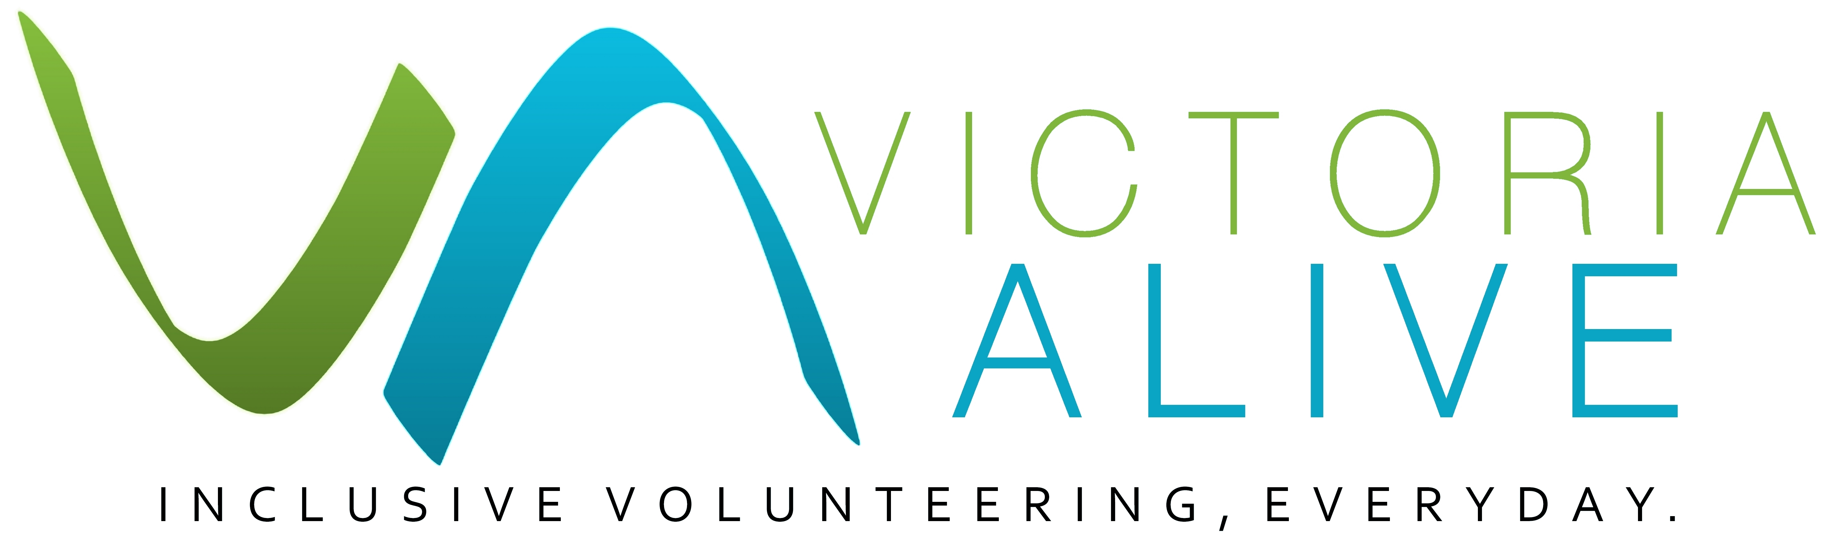

Example Inclusion   
Statement

Title of guide

Guide

***A statement of inclusion for your organisation***

Inclusion in the context of volunteering involves a willingness to adapt tasks to suit a person’s unique abilities, to ensure equal and meaningful participation and to minimise barriers for people with disability in a workspace.

Many people with disability “self-select” out of volunteer roles or do not approach organisations if they do not appear inclusive. Promoting your organisation as inclusive will help open up opportunities for a broader range of people in your community.

The following provides an example statement of inclusion for your organisation to adapt to your own context and endorse. It is something that can be reflected in your organisation’s policies and documents, or feature on your website.

A statement of inclusion will be more powerful when linked back to your organisation’s values, mission and vision. Remember that a statement of intent on its own will not make your organisation inclusive, this requires your organisation to ‘walk the walk’.

**Our Commitment to Inclusion and Diversity – Example**

This organisation welcomes all community members. We wish to create an organisational culture that celebrates diversity in all its forms - diversity in ability and disability, First Nations, gender identity, sexuality, intersex characteristics, age, rurality, socio-economic status, education, ethnicity and faith. We believe everyone has the right to feel safe, welcome and have their life experiences valued. Our team believes our diversity is what makes us stronger. We are committed to embracing our differences, so that people can be who they are, and work to the best of their ability. We are committed to supporting people to reach their volunteering goals and gain fulfillment from their volunteering roles.

**We are committed to ensuring that:**

* every volunteer is welcomed into the organisation
* we affirm that each of us has many layers to our identity and that this diversity is seen as a strength, rather than a difficulty
* we are continually improving our ability to support people of all abilities in their roles
* our facilities, offices, publications, and events are accessible as much as possible, and we are open to feedback for how we can improve accessibility and make reasonable adjustments
* we offer inclusion and diversity training
* our Disability Action Plan / Diversity Action plan is regularly updated and implemented
* our policies and procedures reflect our commitment to accessibility and inclusion.

**ea1**

This guide was published by Volunteering Victoria for the Victoria ALIVE project (2018-2019). For more resources visit: [www.victoriaalive.org.au](http://www.victoriaalive.org.au)   
This guide was peer-reviewed by the Disability Advocacy Resource Unit (DARU). For more information visit: [www.daru.org.au/](http://www.daru.org.au/)  
If you have any suggestions for improvements to this guide, we welcome your input. Contact us by email at: [alive@volunteeringvictoria.org.au](mailto:alive@volunteeringvictoria.org.au) or by phone on 03 8327 8501.   
Guide version 1.0. Published September 2019. Volunteering Victoria is the state peak body for volunteering. ABN 79 378 017 212. [www.volunteeringvictoria.org.au](http://www.volunteeringvictoria.org.au)  
Volunteering Victoria is unable to provide legal advice and this information should not be relied upon as a substitute for legal advice.