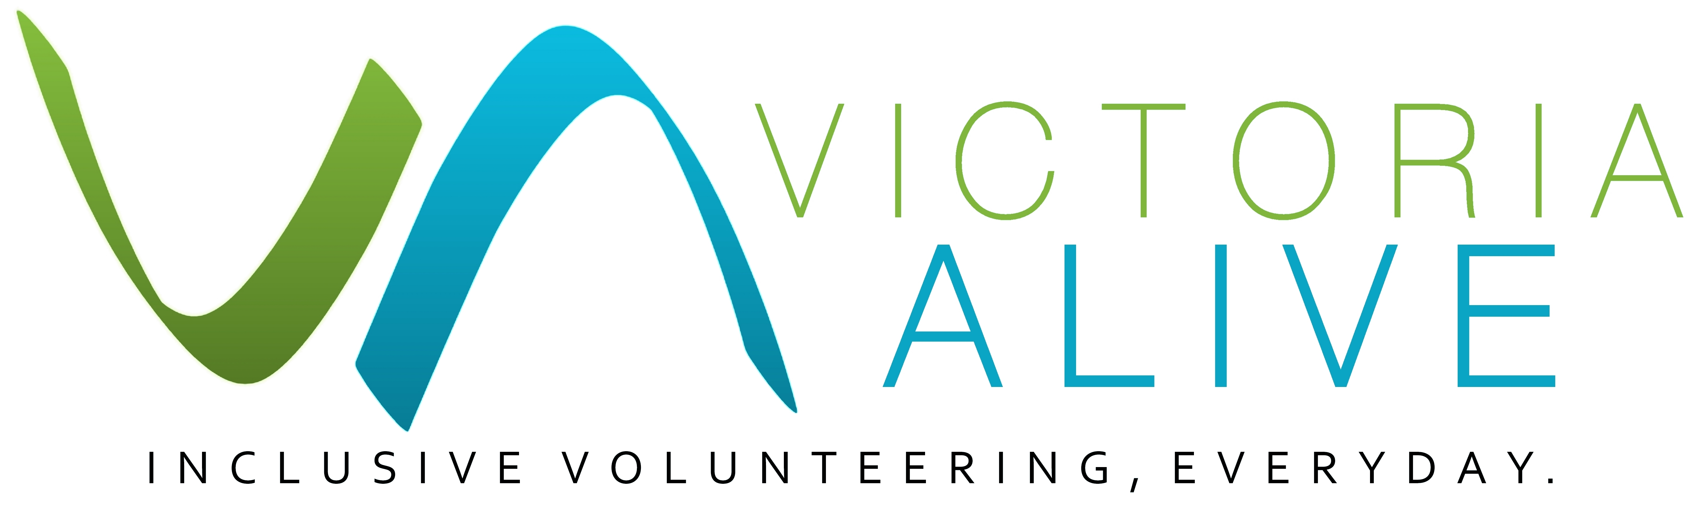**Many people with disability have identified a lack of flexibility in position descriptions and rigid requirements of a role as barriers to volunteering. With more flexible volunteer roles you not only expand your potential for recruitment, you can create an opportunity for a new volunteer, create more resilient communities and potentially change someone’s life.**

Adapting Volunteer Roles

Guide

Title of guide

Guide

### ***Why would I need to adapt a volunteer role?***

Many people with disability have not been given the proper opportunity or support to enter the workforce or undertake a volunteer role. As a manager of volunteers there are simple steps that you can follow to audit your roles (or keep in mind when creating new roles) to make sure you are not creating barriers for people with disability. Even if you do not undertake a complete audit of your volunteer roles, if you have thought about how you could adapt your roles to different needs you will be more prepared for a volunteer with a disability.

In general, there are many benefits of involving people with disability through volunteering. You will have a bigger talent pool, tap into more diverse skills and perspectives for your organisation. People with disability are highly conscious of safety, are loyal to organisations that involve them and take fewer days off.

For some people a volunteer role may be the first step on a journey in coming out of years of isolation before entering the workplace or being part of the community. Volunteering can be a way of reintegrating into society, a way of keeping active and doing something constructive while someone deals with a major phase of transition in their lives.

A small setback for someone might be a much bigger deal for someone else who is coming out of isolation or has faced discrimination in various parts of their life. A seemingly small detail in a volunteer position could act as a barrier to your next potential volunteer.

### Reviewing your volunteer roles

For organisations with a volunteer workforce, volunteer Position Descriptions (PDs) can become standardised over time (‘cookie cutter’ templates), particularly where there is a large volunteer workforce and a lot of administration required. While there are benefits to being consistent and systematic, you should review your position descriptions and be open to making adjustments to volunteer roles where possible.

Guidance on reviewing volunteer roles

Be flexible and adaptable.   
Depending on your program, service and deliverables, you may not have as much flexibility with your volunteer position roles. While it is valuable to be clear about your volunteer needs when designing and advertising a role, the ability to be flexible with regard to hours and tasks can make an enormous difference for volunteers.

Avoid making assumptions.   
While it is natural to make assumptions about disabilities based on your experience, the truth is that every person is different. Two people with the same impairment will likely have different capabilities. Remember to look past someone’s impairment and work with them as an individual.

Focus on the positive and opportunities for development.   
People often focus on what a person with disability can’t do. To change this around, explore your volunteer’s motivations and work to their strengths. Use trial periods as an option if you and your volunteer are not sure if they are able to fulfil the role. This will help avoid unintentionally determining your volunteer’s limitations. Trials will also help you to stop thinking in terms of liability and refocus to your volunteer’s contribution.

Listen to your volunteers.   
You are unlikely to solve every problem before it arises. This is why it is critical to talk to your volunteers with disability and learn from them. They are the experts in their own right and your organisation can benefit from this valuable experience. Ask your volunteers how you could adapt your volunteer roles if needed. A good working relationship with respectful, open communication will be more effective that attempts to adapt a volunteer role without their input.

### ***Practical Tips***

* Does your volunteer Position Description template require the volunteer to have a drivers licence? If this is not necessary, consider removing this requirement.
* Does your volunteer need to perform heavy lifting? Sometimes PDs have this in there for risk management purposes when the role does not require it.
* Could the role be undertaken with a buddy/assistant if the volunteer needs some minimal support?
* Does your Position Description include accessibility information?
* Do you promote yourself as an inclusive organisation? You can include a values statement on your volunteer Position Descriptions. For example, “[our organisation] values diversity in the workplace. We encourage applications from women, people with diverse cultural backgrounds and it is our policy to consider workplace adjustments for qualified applicants with disabilities. We are a LGBTQI friendly organisation.”
* Are you able to break up long shifts into smaller ones?

### **Case studies**

**Jenny** is a retired professional accountant with a vision impairment. The organisation Jenny applied to volunteer in did not feel confident that it had the resources to support Jenny as a volunteer. However, the only support Jenny required was to be assisted to and from the bus stop to the office on the first two days of volunteering. With her own assistive software Jenny is able to contribute to this not-for-profit organisation without further resources required.

**Bob** is a volunteer with mental health issues. While most weeks he can volunteer for a full day, he is currently going through a rough patch. Making it through a full day shift feels a lot harder during that time. The organisation he volunteers understands Bob’s issues and breaks up the shifts to smaller sizes.

**Shane and Tom** are both on the autism spectrum. Shane began a volunteering role in an organization helping out with administration work. To the surprise of some of the staff Shane was happy to do volunteering tasks that many other people did not like to do because they were repetitive, such as photocopying and data entry. Over time the organisation hired Shane as an administration officer as he exceled at the work. Tom however, while he is also on the autism spectrum, does not enjoy doing this kind of volunteer work. Instead, Tom enjoys doing creative work and has great talent as an artist. Therefore, the organisation has provided Tom with volunteering opportunities to undertake visual designing of the organisation’s logo, posters and website.

**More information**

National Standards for Volunteer Involvement: volunteeringaustralia.org/wp-content/uploads/National-Standards-Document



Published by Volunteering Victoria for the Victoria ALIVE project (2018-2019). For more resources visit: www.victoriaalive.org.au

This guide was peer-reviewed by the Disability Advocacy Resource Unit (DARU). For more information visit: www.daru.org.au/

If you have any suggestions for improvements to this guide, we welcome your input. Contact us by email at: alive@volunteeringvictoria.org.au or by phone on 03 8327 8501.

Guide version 1.0. Published September 2019. Volunteering Victoria is the state peak body for volunteering. ABN 79 378 017 212. www.volunteeringvictoria.org.au

Volunteering Victoria is unable to provide legal advice and this information should not be relied upon as a substitute for legal advice.

03 8327 8501 | alive@volunteeringvictoria.org.au | victoriaalive.org.au