**olunte** 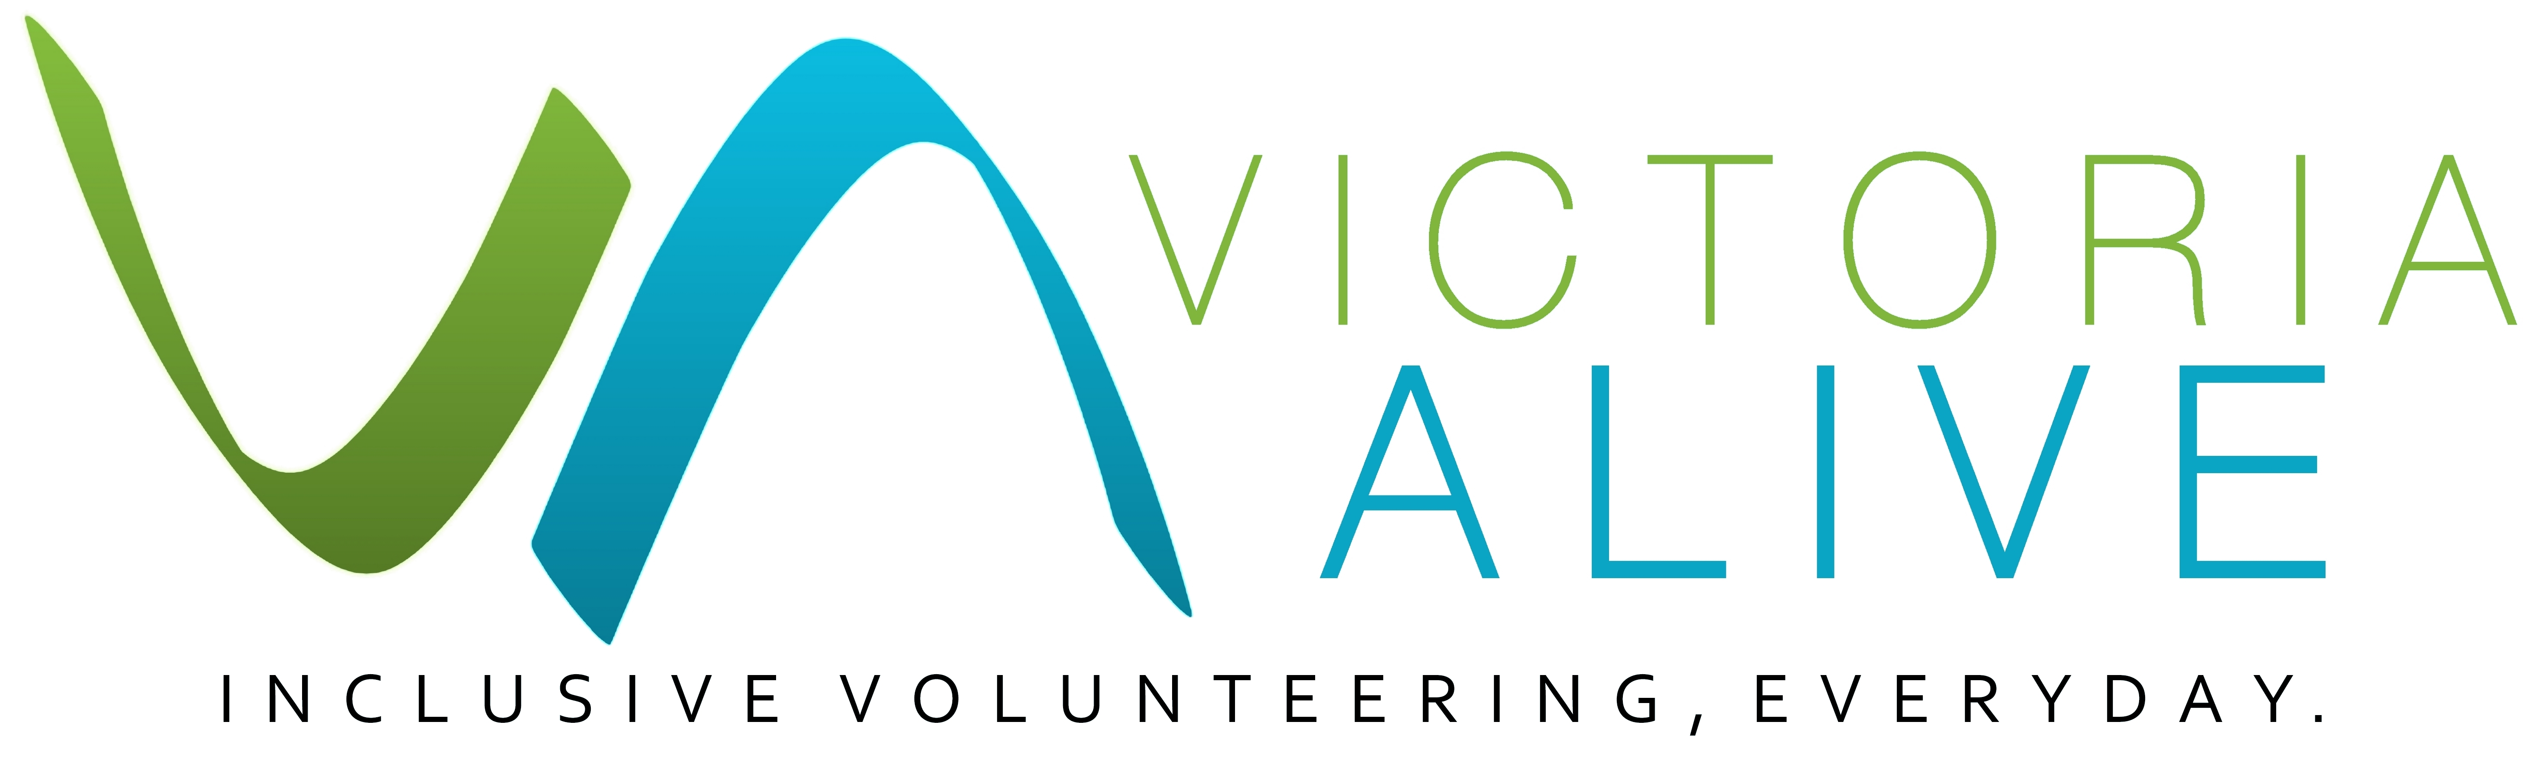

Is Your Organisation Accessible?  
Guide

Title of guide

Guide

**1 in 5 Australians identify as having a disability. As people with disability participate more in our communities through volunteering, there are higher expectations for organisations to be accessible as we collectively raise our standards. Accessibility no longer simply means having a wheelchair ramp to your door – contemporary forms of disability inclusion and accessibility are more encompassing.**

This checklist will to help you assess whether your organisation is accessible to all, including volunteers with disability. The checklist will also help you to consider improvements to your workspace or be more prepared to make reasonable adjustments for your volunteers.

You may not be able to tick every box in the list below. However, having a greater awareness of these considerations will benefit both you and your volunteers. Understanding the accessibility features and limitations of your workplace will allow you to provide potential volunteers with key information and the confidence to make their own decisions.

Asking your volunteers what assistance they need to best do their role is key. Where there are limitations, with open communication and a respectful relationship there is likely a way you and your volunteers can work around a barrier and make the volunteer experience positive for all.  
 ***Checklist***

Accessible culture:

* Do you have a disability advisory group or a process for people to provide feedback and suggest improvements about making the organisation more accessible?
* Does your organisation have a Disability Action Plan (sometimes called an Accessibility Action Plan) or Diversity Action Plan which makes commitments to ongoing improvements for your volunteers with disability?
* Are all abilities valued and all people regarded equitably?
* Does your organisation promote diversity in its workforce, both paid and volunteer?
* Is your organisation open to disability awareness training?

Accessible communication:

* Have you asked your volunteers with disability what they need to best do their role?
* Are all meeting notes, documents and forms circulated with time to digest information and complete tasks?
* Do meetings allow time for people with processing or language difficulties to comment or ask questions?
* Is your organisation’s internal and external communication and marketing inclusive and accessible for people with disability? Do e-mails with images have captions? Is Easy English available and used?
* Are policies and procedures, including emergency procedures, clear, transparent, written and available in different formats, i.e. Large print, Easy English

[You can find resources to make your meetings and processes more accessible here](https://voiceatthetable.com.au/resources/ensure-meetings-inclusive/)

Accessible Processes:

* Does your organisation encourage job applications from people with disability?
* Is your organisation willing to adjust or re-design the role according to workers’ abilities?
* Are your processes and procedures flexible to adapt to people of diverse abilities?
* Is the organisation open to engaging with JobAccess to make reasonable adjustments to the workspace?
* Is your organisation open to disability awareness training?
* Does your organisation have a commitment to accessibility and inclusion policies regarding disability inclusion?

[Read more about making your organisation inclusive](https://www.ourcommunity.com.au/article/view_article.jsp?articleId=3489)

**Physical environment:**

#### Does your organisation have an accessible entrance, including: [ramps which meet legislated standards](http://www.aphref.aph.gov.au/house/committee/laca/disabilitystandards/exhibits/exhibit02.pdf) , doorbell at reachable height, smooth paving and tactile surfaces where appropriate?

* Are accessible parking bays nearby?

#### Are automatic doors installed?

#### Are doors wide enough to allow for mobility aids?

#### Is signage intuitive and of appropriate size?

#### Does a person with disability have access to an accessible bathroom i.e. enough turning space, grabrails beside and behind the toilet, and a reachable washbasin?

* Are all lift buttons large with braille and at a suitable level for wheelchair users?
*  Are handrails present in all lifts and are announcements heard when lift doors are opening, closing or reaching levels?
* Are there opportunities for people to get up and move around frequently?
* Is your environment scent-free for the benefit of those with multiple chemical sensitivities?
* Can temperature controls i.e. heating and air conditioning, be used independently?

#### Is a quiet/chill-out space available if required?

[Read more about making Australian physical environments accessible](https://dfat.gov.au/about-us/publications/Documents/accessibility-design-guide.pdf)

Assistive Technology:

#### Is a hearing loop or interpreter available if required?

* Are you aware of assistive devices for people with low vision or vision impairment, such as screen magnifiers?
* Is a support worker welcome to accompany the volunteer?

***Upgrading your workspace***

For guidance on where to seek funding to upgrade your building or improve the accessibility, visit:

[www.acedisability.org.au/resources-for-providers/funding-options.php](http://www.acedisability.org.au/resources-for-providers/funding-options.php)

[www.vic.gov.au/grants](http://www.vic.gov.au/grants)



This guide was published by Volunteering Victoria for the Victoria ALIVE project (2018-2019). For more resources visit: [www.victoriaalive.org.au](http://www.victoriaalive.org.au)   
This guide was peer-reviewed by the Disability Advocacy Resource Unit (DARU). For more information visit: [www.daru.org.au/](http://www.daru.org.au/)  
If you have any suggestions for improvements to this guide, we welcome your input. Contact us by email at: [alive@volunteeringvictoria.org.au](mailto:alive@volunteeringvictoria.org.au) or by phone on 03 8327 8501.   
Guide version 1.0. Published September 2019. Volunteering Victoria is the state peak body for volunteering. ABN 79 378 017 212. [www.volunteeringvictoria.org.au](http://www.volunteeringvictoria.org.au)  
Volunteering Victoria is unable to provide legal advice and this information should not be relied upon as a substitute for legal advice.

Some of the issues that should be considered include: changes in organisation needs, new directions or goals, and the role of the volunteer.

Evaluation of the volunteer and mentor/buddy partnerships is also important. Getting feedback from those involved provides valuable information that can be used to make adjustments to the program if needed.

Questions for the volunteer with disability

* Are you comfortable working with your mentor/buddy?
* Are you happy with the level of advice and guidance you have received about the workplace and your role?
* Have your accessibility needs been taken into account?
* Are there any suggestions you would make to improve your experience at this organisation?

Questions for the mentor/buddy

* Is the work you are doing in this role as you expected? If not, is it more or less?
* Are you happy in this role?
* Is the role effecting your other duties more than you expected?
* Is the volunteer performing to expectations?
* What changes would you recommend the organisation makes to improve this process?

**Mentor/Buddy agreement**

* If you are looking to hire a person with disability and you have identified an employee to act in the role of a buddy/mentor, you might want to consider creating an ‘agreement’ that the mentor/buddy agrees to before the volunteer starts.