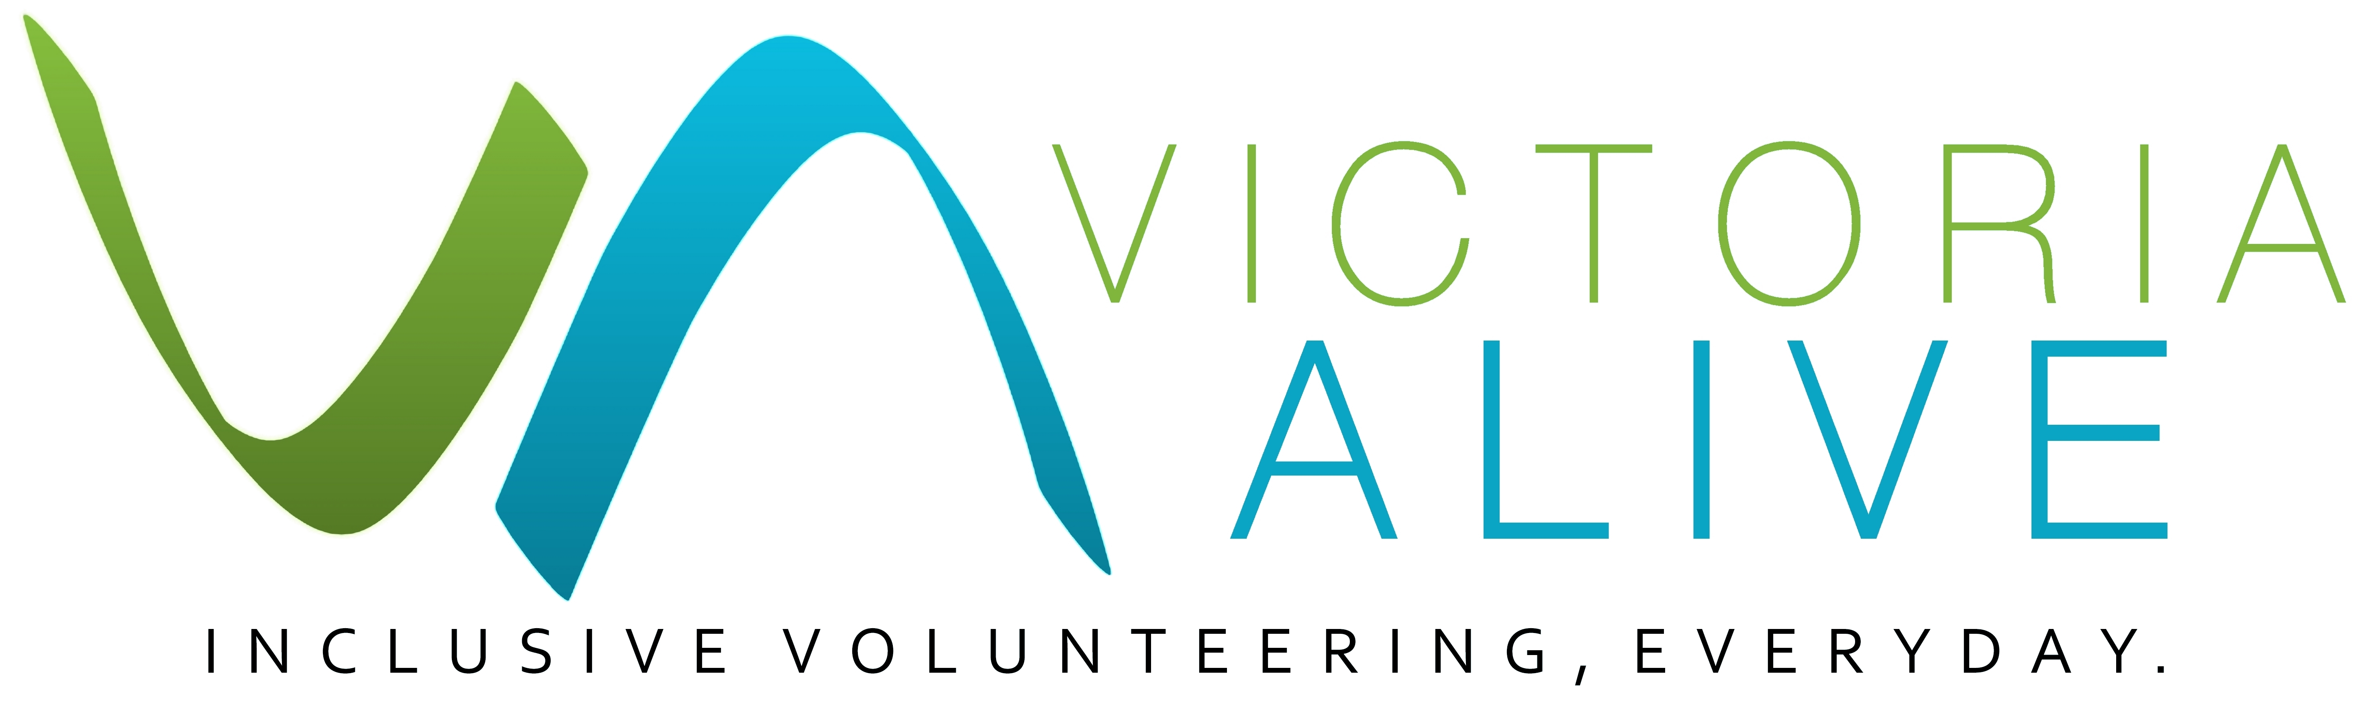
If your organisation is considering providing volunteer opportunities for people with disability, implementing a mentor or buddy system is a great way to ensure these volunteers make the transition into your workplace, culture and role in the smoothest way possible.
Using Mentors, Buddies or Other Support
Guide
Having a mentor or buddy program at your organisation also provides new opportunities for existing employees or volunteers and can be a very rewarding experience for the right person.

This guide will provide you with some ideas for implementing a mentor or buddy system in your volunteer program, with a focus on providing support for volunteering roles for people with disability.

Why implement a mentor or buddy system in my organisation?
Many organisations, such as small, unincorporated and community-based organisations, feel unprepared or have concerns when taking on board a volunteer with a disability. Some of the concerns include:
- A lack of ability to have contact time with the volunteer
- Not enough organisational resources
- A lack of understanding about a person’s specific disability and their requirements.
While these concerns might hold back an organisation from bringing on board a volunteer with disability, often the only support required is common sense, understanding and a friendly face.
There are many significant benefits that volunteers who have disabilities can provide to organisations. This includes more effective use of time and resources. Therefore, making the time to understand disability-related needs is well worthwhile.

The benefits of a mentor/buddy system for your volunteers
Settling into a new role can be a nerve-wracking experience for anyone, and especially for some people with disability. Improving the experiences of a volunteer’s time at your organisation will likely lengthen the time that they volunteer for your organisation.
Mentors, buddies and assistants will help volunteers settle into their role as comfortably as possible. Support structures like mentors or buddies can set the foundations for long-term success.
Mentoring, buddies, shadowing and assistants are some forms of support structures that you can set up for a volunteer, freeing up your time and giving you more peace of mind. Mentor/buddy systems can also alleviate uncertainly surrounding tasks which will result in fewer mistakes. A buddy is a friendly face who can boost the morale of the individual volunteer, and which contributes to a positive workplace culture
Having a mentor/buddy program at your workplace can also provide new work experience opportunities for current employees, keen to develop their professional skillsets. In the case of being a mentor/buddy to a volunteer with disability, it can also be a very rewarding experience for the right person.
Your organisation likely already uses one or many forms of these kinds supports. All of these arrangements can be formal or informal.
However, note that a mentor, buddy or other support system is not a replacement for a professional disability support worker or a carer for someone with high needs. Also, do not assume that a person with a disability requires a mentor, buddy or other support that other volunteers don’t have.

The roles of mentors, buddies and other supports
A mentor/buddy role is a relationship which involves a more experienced person helping a less experienced person to achieve their goals. A mentor/buddy is a person who will listen, provide advice and guidance to volunteer mentees when requested.
Some examples of support arrangements include:
Mentoring:
Role: focussing on a volunteer’s overall development.
Example: regular contact but spaced apart, for example every month or two months.
Buddy:
Role: assists the volunteer with more practical advice on how to do the volunteer role or helps them with minor supports they might need.
Example: is located close to the volunteer and is the go-to person for basic questions. Takes the volunteer out for coffee every week and checks with them.

Assistant:
Role: this could be an employee or another volunteer who can provide basic help.
Example: Assisting a person with low vision to and from public transport at the start and end of every volunteer shift.
Shadowing:
Role: working with the volunteer simultaneously for a limited period. Particularly useful for new volunteers or volunteers undertaking a new task.
Example: when the new volunteer starts, they shadow an experienced volunteer for two shifts. They then do two shifts with the experienced volunteer shadowing them until they are comfortable in the role.

The mentor role
One-on-one mentoring is a great way to support volunteers with a disability. A mentor's role is vital in how well the volunteer feels included in the organisation, valued and understood.
Mentors should be patient, reliable, friendly, respectful and understanding of individual needs. They should have a firm belief that people with disability make valuable contributions to society.
The type of person who would be ideally suited to the role of a mentor or buddy for a volunteer with disability could be generally described as having the following attributes:
- Someone who is a champion for disability rights
- Be comfortable with themselves
- Honest, committed, trustworthy and respectful
- Have good communication skills
- Is good at setting goals and has the ability coach the volunteer to reach them
- Has a personal style that is compatible with the volunteer’s needs
- Someone who enjoys a challenge.
The buddy role
Buddies help integrate new volunteers with disability and assist in developing a positive work culture by ensuring the volunteers feel welcomed. They can provide guidance on company culture, the do’s and don’ts within the office and be a main go-to for any questions the volunteer might have. They should be interested in working with the volunteer to learn about any assistance they need and promote greater disability awareness within the organisation.

For example, general tasks such as making introductions to staff, showing the volunteer around the office/workplace and dealing with questions can be completed by a mentor/buddy.
Roles and responsibilities:
- While it is not expected that the buddy spends all day with the volunteer, they should try to make contract with them regularly to ensure they are coping
- Encourage and assist the volunteer in a professional manner
- Be approachable and accessible
- Be aware of workplace policies and processes
- If possible, the mentor should be able to influence tasks allocated to the volunteer or better identify training opportunities, to ensure their skills are fully utilised
- Be a role model on how employees should perform and act in the workplace.
You and your volunteers do not need to be experts on various forms of disability, but it is helpful to invest time to get a foundational understanding about disabilities in general and more understanding about the disabilities your specific volunteers have. For a buddy or assistant role in particular, you could provide disability awareness training in the specific disability.
Mentor/Buddy agreement
If you want to formalise the mentor/buddy/support arrangements, you may want to create an agreement for the mentor/buddy at the outset of the relationship. This will clarify expectations for each person and helps to more formally acknowledge the contribution of the mentor or buddy.
Information you may wish to include in the agreement might be:
As a mentor/buddy, I will strive to:
- Make contact with the volunteer regularly to ensure they are coping
- Encourage and assist the volunteer in a professional manner
- Be approachable and accessible
- Be aware of workplace policies and processes
- Influence tasks allocated to the volunteer or better identify training opportunities, to ensure their skills are fully utilised
- Be a role model on how employees should perform and act in the workplace.
As a mentor/buddy:
- I am clear on the expectations of this role
- I understanding that if this role extends outside of these expectations, I will speak to my supervisor.

Evaluating the mentor/buddy program
To ensure that the mentor/buddy program remains relevant to the volunteer and the organisation, it is useful to evaluate the processes you have in place after each volunteer role ends, or, if the role is ongoing, after a few weeks and then every month or so.
Some of the issues that should be considered include changes in organisation needs, new directions or goals, and the role of the volunteer.
Evaluation of the volunteer and mentor/buddy partnership is also important. Getting feedback from those involved provides valuable information that can be used to make adjustments to the program if needed.
Questions for the volunteer with disability
- Are you comfortable working with your mentor/buddy?
- Do you feel respected by your mentor/buddy?
- Does your mentor/buddy listen to you?
- Are you happy with the level of advice and guidance you have received about the workplace and your role?
- How clear was the advice and guidance you received?
- Have your accessibility needs been taken into account?
- Are there any suggestions you would make to improve your experience at this organisation?
Questions for the mentor/buddy
- Is the work you are doing in this role as you expected? If not, is it more or less?
- Are you happy in this role?
- Is the role effecting your other duties more than you expected?
- Is the volunteer performing to expectations?
- What changes would you recommend the organisation makes to improve this process?
03 8327 8501 | alive@volunteeringvictoria.org.au | victoriaalive.org.au

Further help
www.bgkllen.org.au/wp-content/uploads/2017/12/taking-that-extra-step-web-version.pdf
https://inclusivevolunteeringorgau.files.wordpress.com/2018/03/creating-an-inclusive-workplace-for-workers-with-disabilities-2.pdf
https://inclusionmelbourne.org.au/resource/taking-that-extra-step-a-volunteer-manual/
www.fairwork.gov.au/how-we-will-help/templates-and-guides/templates
http://daru.org.au/

Published by Volunteering Victoria for the Victoria ALIVE project (2018-2019). For more resources visit: www.victoriaalive.org.au
This guide was peer-reviewed by the Disability Advocacy Resource Unit (DARU). For more information visit: www.daru.org.au/
If you have any suggestions for improvements to this guide, we welcome your input. Contact us by email at: alive@volunteeringvictoria.org.au or by phone on 03 8327 8501.
Guide version 1.0. Published [Month] 2019. Volunteering Victoria is the state peak body for volunteering. ABN 79 378 017 212. www.volunteeringvictoria.org.au
Volunteering Victoria is unable to provide legal advice and this information should not be relied upon as a substitute for legal advice.

